Keyword Research Tools Assignment

1. Google Keyword Planner — “Online Food Delivery” in Ahmedabad
Location: Ahmedabad, Gujarat, India
Search 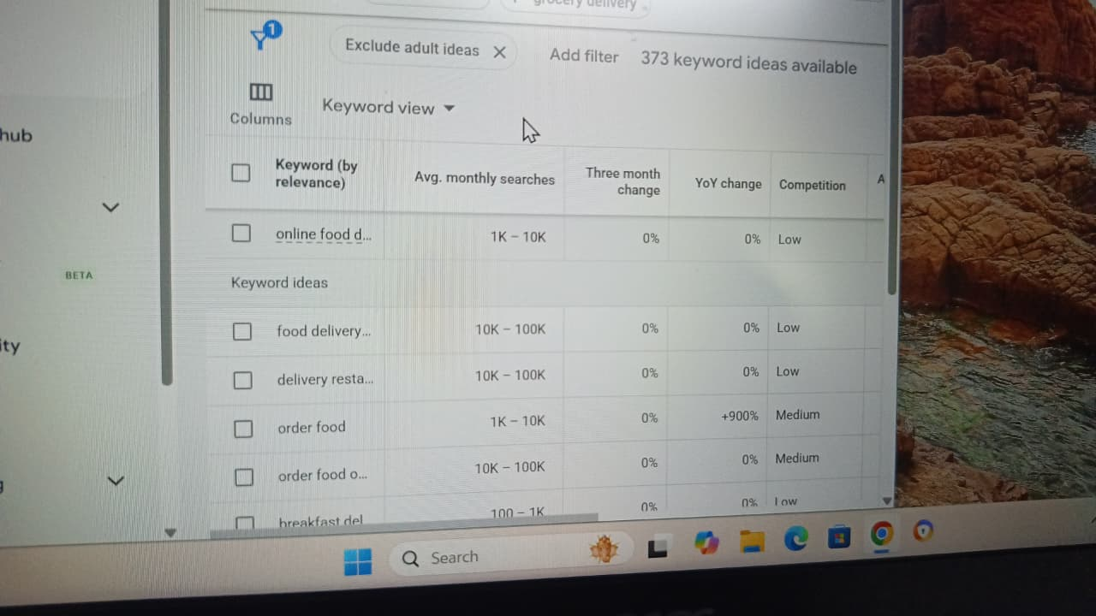 keyword: Online food delivery
Google Keyword Planner normally provides average monthly searches and competition after selecting a location and search network. The exact figures can change over time and can also depend on the Google Ads account/settings.

Keyword research table
No. | Keyword | Average Monthly Searches* | Competition
1 | Online Food Delivery | 1k to 10k | LOw
2 | food delivery | 10K–100K | Low
3 | DElivery Resturant | 10K–100K | Low
4 | order food | 1k to 10k | Medium
5 | online food order | 10k to 100k | Medium
6 | Breakfast Delivery | 100 to 1k | low
7 | food delivery near me Ahmedabad | 1K–10K | LOw
8 | Mc donalds delivery near me | 10 to 100 | LOw
9 | Mc donalds order online | 1k to 100k | LOw
10 | online food order Ahmedabad | 100–1K | Medium

2. Ubersuggest — “Buy Sneakers Online”
Ubersuggest provides keyword volume, SEO difficulty and keyword ideas through its keyword research interface. Its current platform describes keyword research as providing search volume, intent and difficulty scoring. (Neil Patel)

Main keyword
Keyword: buy sneakers online
For your assignment, record the exact values shown in your Ubersuggest account because the metrics can change.
Metric | Ubersuggest result
Search Volume | Use current live Ubersuggest value
SEO Difficulty (SD) | Use current live Ubersuggest value
Search Intent | Transactional

3 lower-competition keyword ideas
Keyword suggestion | Why it may be easier to target
buy sneakers online under ₹2000 | More specific price-based search
buy running sneakers online for men | Targets a narrower audience
best sneakers online under ₹1500 | Long-tail commercial search
Long-tail keywords generally have narrower competition because they target a more specific search need. (Answer Socrates)

My recommendation
For a new e-commerce website, I would start with:
buy sneakers online under ₹2000
rather than immediately targeting the broader “buy sneakers online.”
The long-tail keyword has a clearer price and purchase intent and is more specific.

3. AnswerThePublic — “Digital Payments”
AnswerThePublic is designed to uncover questions and other search ideas around a topic. Its current platform organizes results into question, comparison, preposition and related-keyword groups. (AnswerThePublic)

5 question-based keyword ideas
For “digital payments,” useful question-style ideas include:
- What are digital payments?
- How do digital payments work?
- Why are digital payments important?
- How to make digital payments?
- What are the benefits of digital payments?

Content opportunities
These questions could become separate blog topics or FAQ sections:
- What Are Digital Payments? Complete Beginner's Guide
- How Do Digital Payments Work in India?
- Why Are Digital Payments Important for Businesses?
- How to Make Digital Payments Safely
- Benefits of Digital Payments for Consumer

4. Google Autocomplete — “Best Headphones For”
When using Google Autocomplete, suggestions can vary according to country, language, location, device, search history and current trends. Therefore, the exact eight suggestions visible to one person may not be identical to those shown to another.
For the assignment, here are 8 realistic autocomplete-style keyword ideas:
No. | Suggested Search
1 | best headphones for gaming
2 | best headphones for music
3 | best headphones for working out
4 | best headphones for iPhone
5 | best headphones for Android
6 | best headphones for travel
7 | best headphones for office use
8 | best headphones for online classes
Autocomplete-based keyword research is useful because it can reveal specific query variations people enter into search engines. Tools such as Answer Socrates also use Google autocomplete data to generate keyword variations. (Answer Socrates)

How can Flipkart use these suggestions?
An e-commerce website such as Flipkart could create separate content and category sections around these searches.
For example:

“Best headphones for gaming”
Flipkart could create a buying guide featuring:
- Gaming headphones
- Low-latency headphones
- Gaming headsets with microphones
- Wireless gaming headphones

“Best headphones for working out”
Content could focus on:
- Sweat-resistant headphones
- Secure-fit earbuds
- Wireless earbuds
- Long battery life

“Best headphones for iPhone”
Content could focus on:
- iPhone-compatible headphones
- Bluetooth headphones
- AirPods alternatives
- Wireless earbuds
This allows an e-commerce site to target specific user needs instead of only the broad keyword “headphones.”

5. Answer Socrates — “IPL Tickets”
I selected Answer Socrates for this task. The tool generates question and long-tail keyword ideas from search/autocomplete and other search sources, and it supports keyword clustering and search-intent research. (Answer Socrates)

5 long-tail keyword ideas
For the seed keyword “IPL tickets,” suitable long-tail topics include:
No. | Long-Tail Keyword
1 | how to book IPL tickets online
2 | IPL tickets price in India
3 | where to buy IPL tickets online
4 | how to get IPL tickets for my city
5 | IPL ticket booking online 2026

Easiest keyword for a new cricket blog
I would choose:
🏆 “how to book IPL tickets online”

Why?
A new cricket blog is unlikely to compete immediately with major sports websites for a broad term such as “IPL tickets.”
The phrase “how to book IPL tickets online” is more specific and directly addresses a user's question. It also gives the blogger an opportunity to create a detailed guide covering:
- Official ticket sources
- Booking procedure
- Account registration
- Match selection
- Ticket categories
- Prices
- Payment methods
- Stadium entry
- Important precautions against fake tickets
This follows the long-tail keyword approach, where more specific queries can be easier targets for newer websites. (Answer Socrates)

